**Interned in a multinational corporation abroad**

Posted by David Hofmann  
Date: 19 September 2022

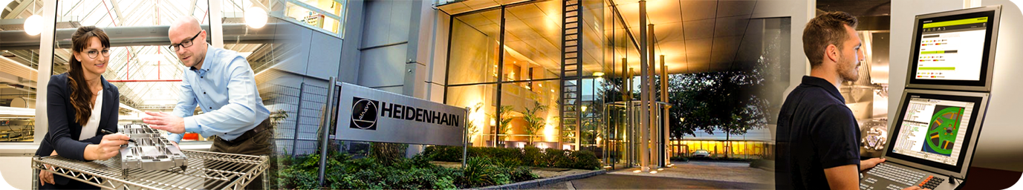During a period of 4 weeks this summer season I got the amazing opportunity to work for the Dr. Johannes Heidenhain Ltd., directly at the headquarters, located in Traunreut. The company is one of the biggest hidden champions in Germany, which is defined as a relatively unknown large company. They are a global market leader specialized in the measurement industry as well as drive technology.

During the internship I was able to work in different departments. The first department I worked in, was responsible for the output and return of computers, notebooks and technical devices for employees. Furthermore, I installed an encrypted Windows operating system on every new notebook and computer via the network. This is due to cyber security reasons. The main IT warehouse was also partially managed by me. After 2 weeks I switched to a department called “Mobile Device Management & Software Approval”. The scope of duties covers the issuance of company intern mobile phones and approving software. Mobile phones had to be configured beforehand using appropriate software.

Because of duties outside the office, I was able to see loads of various sections of the company premises. I had a lot of conversations and exchanged experiences with some of the employees. I loved the delicious and inexpensive lunch the cafeteria had to offer.

I personally consider this as a great way to gather a lot of job experience besides school, which is required for a successful career in the future. I saw the work   
routine of different IT jobs, I couldn’t imagine before.   
This will help me with the selection of the course I want to study at the university. It’s also very nice to earn some extra pocket money.